Experiment: Create your First AWS S3 Bucket and Upload Content to Bucket and Manage their Access and Create Static Website using AWS S3

Versionning of S3 bucket

Create two bucket

Namely i.e 58a-newbucket ,58a-newbucket2

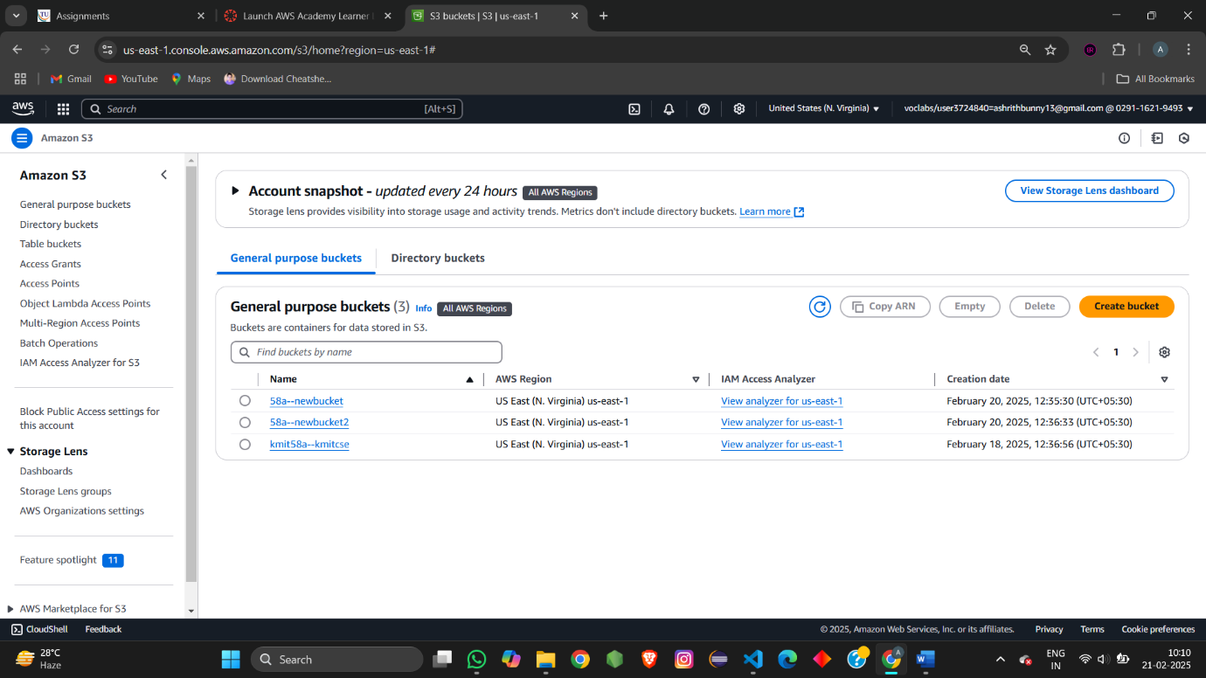

For bucket2 🡪go to properties

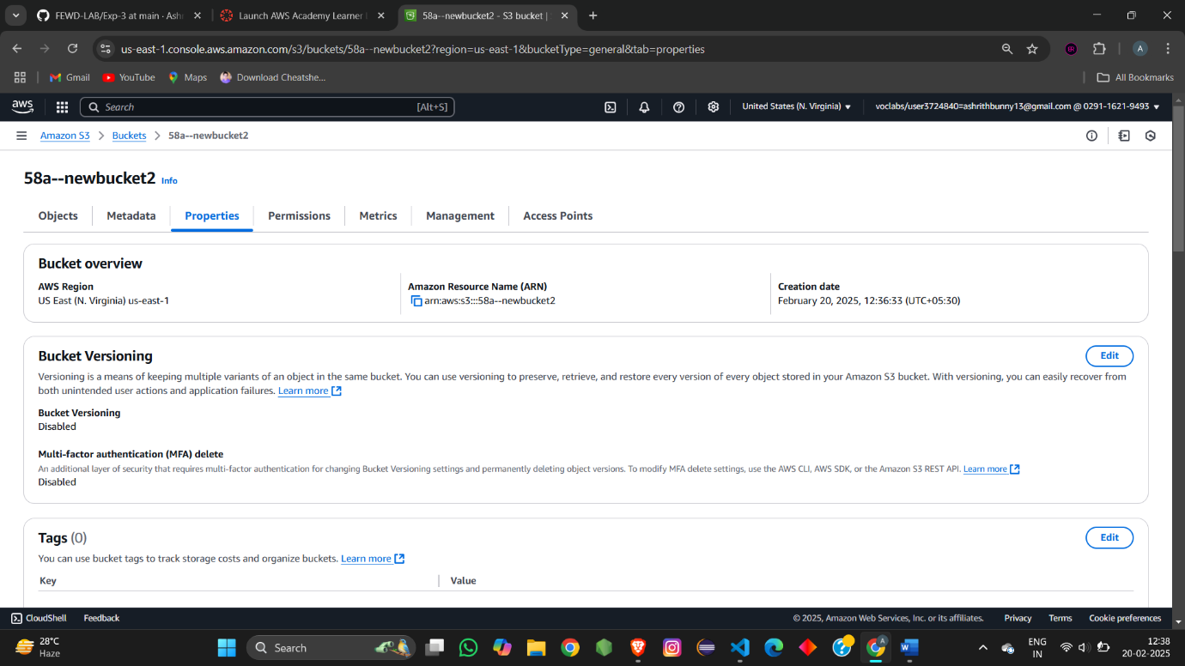

Edit bucket versioning – Edit select enable

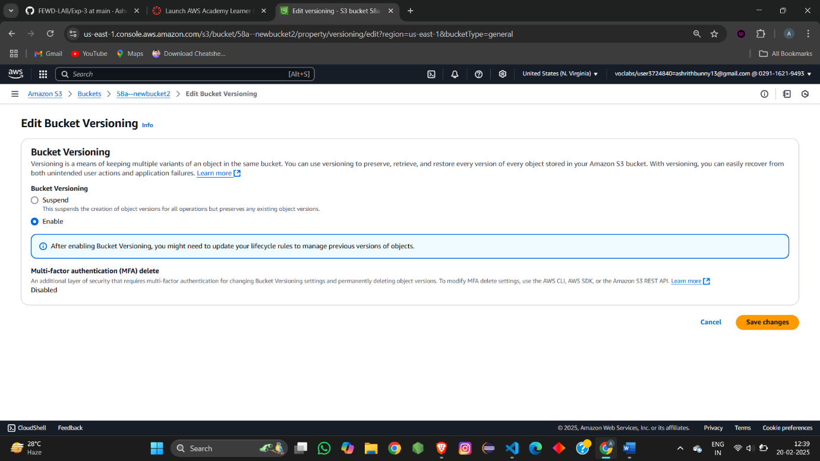

Now upload the object in both the bucket same objects

For bucket 1:

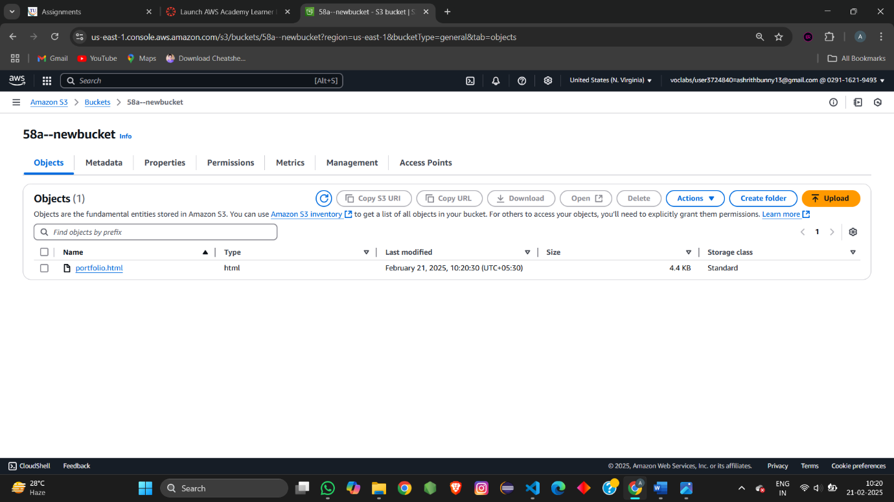

For bucket2:

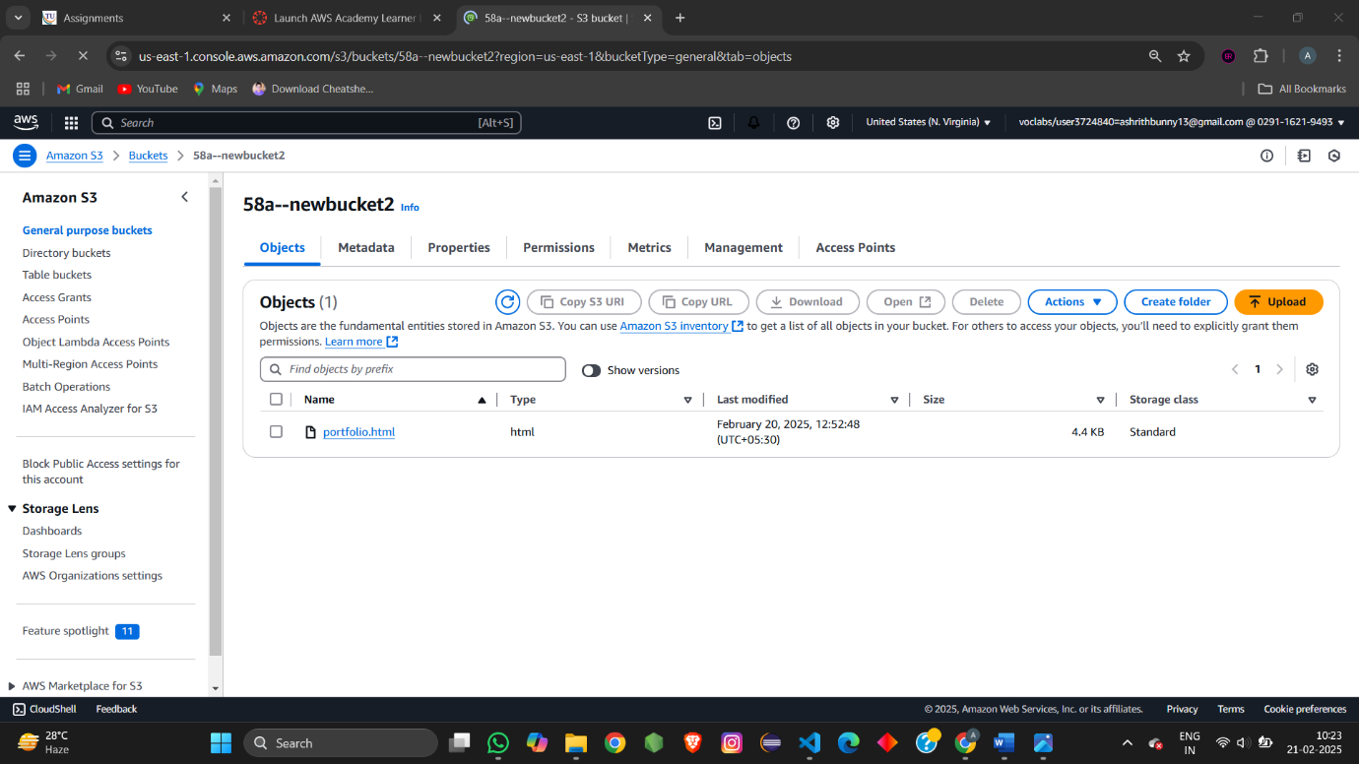

Now delete the anyone single object from object in both i.e similar object to be deleted

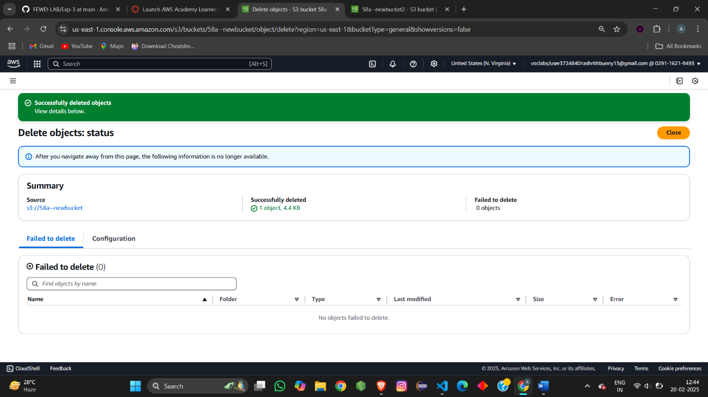

Object get deleted ,now check show version

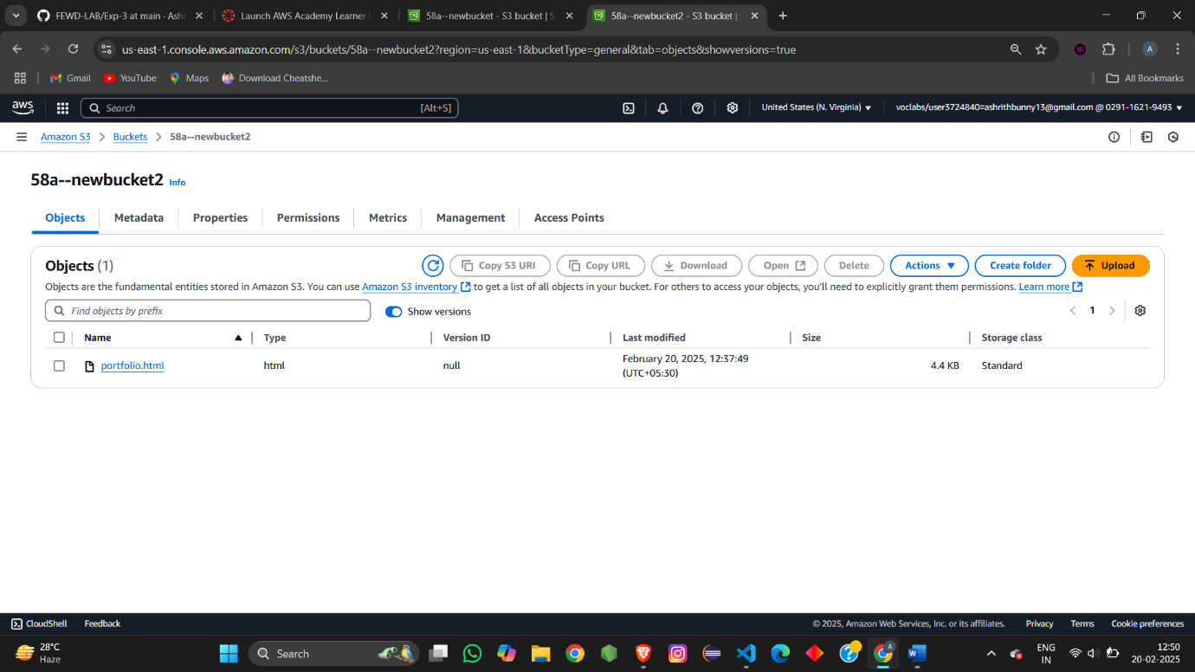

As we enabled versioning for bucket2 than check show version:

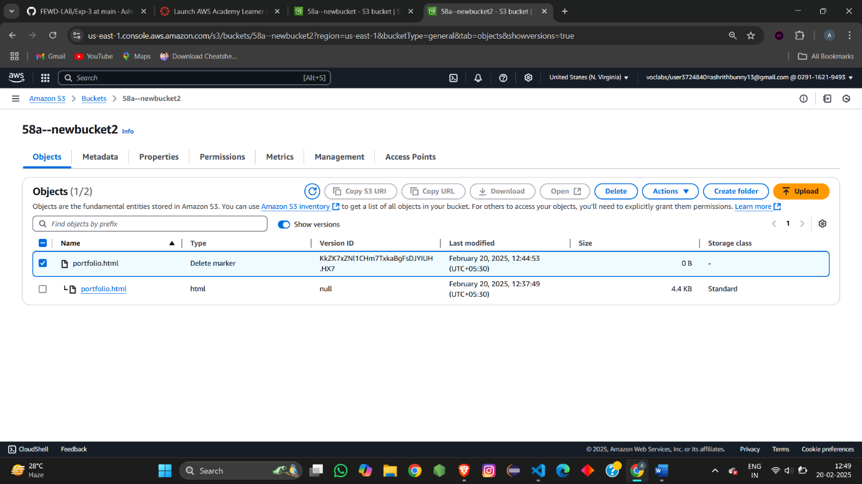

You can find the deleted image as marker.

Now if you delete the marker we will get the deleted file back

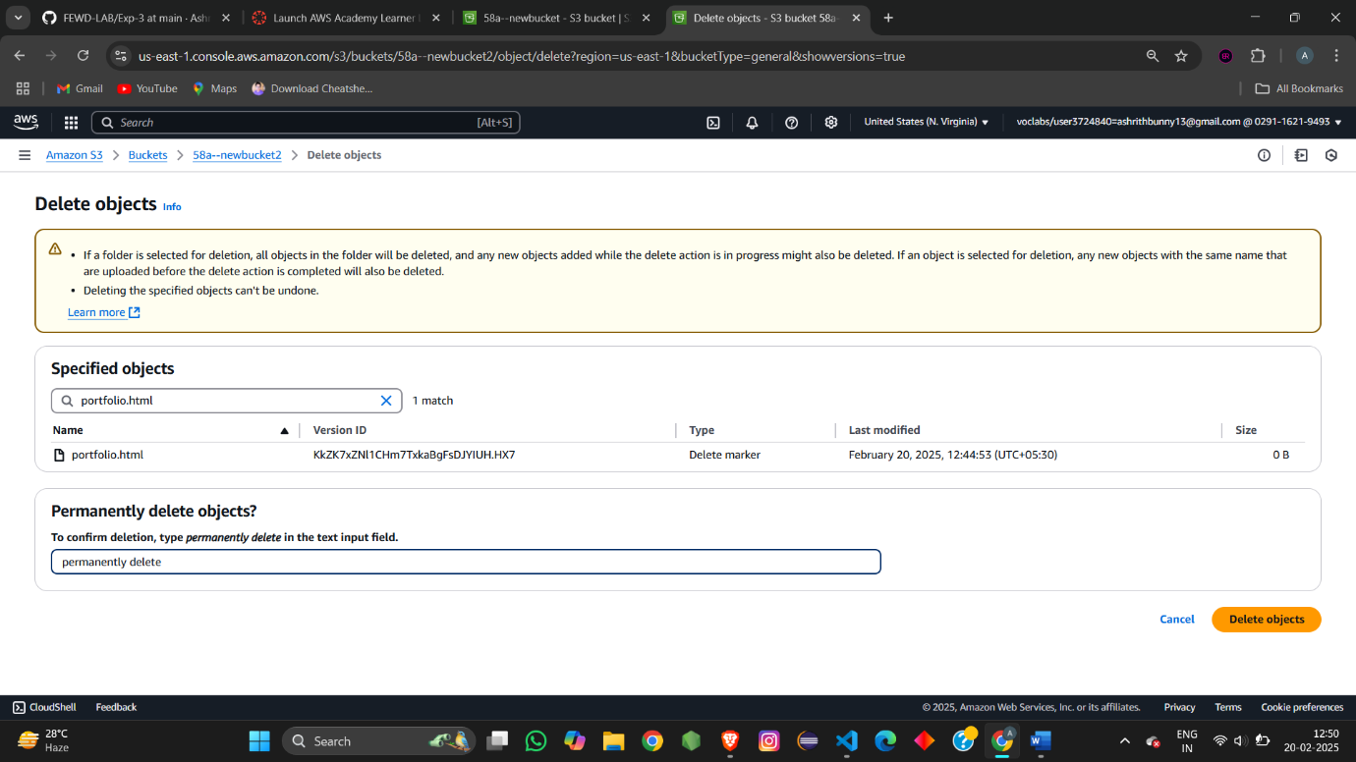

Now you can see the file is restored



This restoring of files can be done if we enable versioning

As bucket1 is not enabled with versioning hence we are unable to restore the deleted files i.e. permanently deleted.



We are unable to see show version for bucket1 because versioning is unable.

Static webhosting: in S3 bucket

Create a bucket for static webhosting.

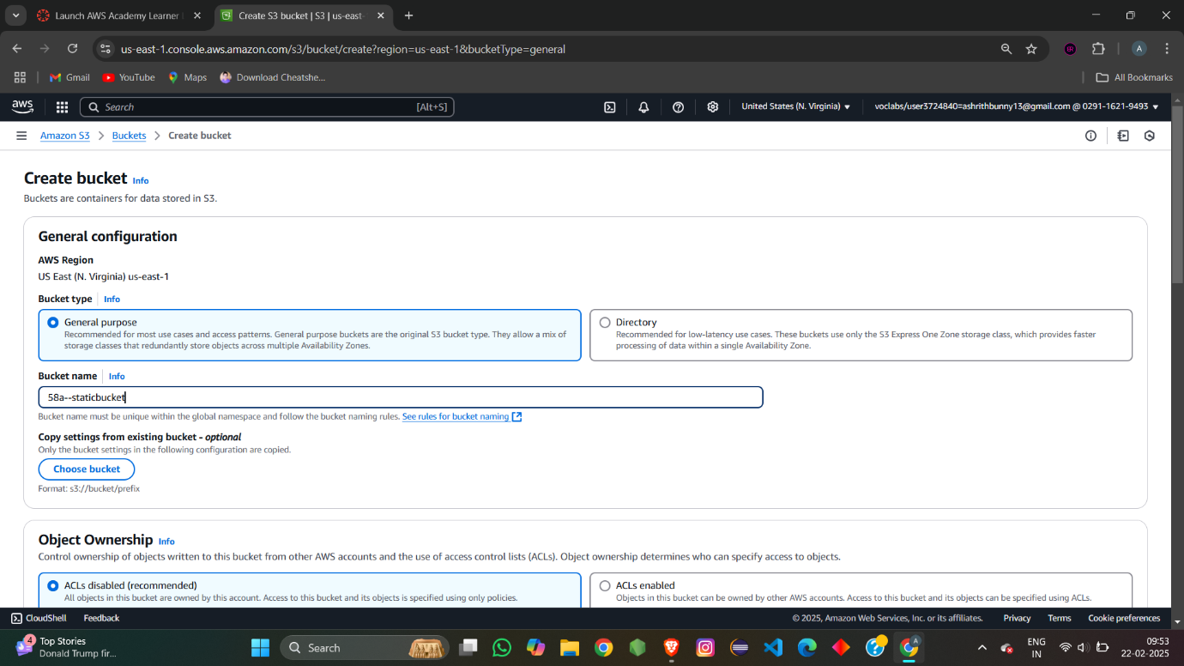

Edit static webhosting in properties of the bucket

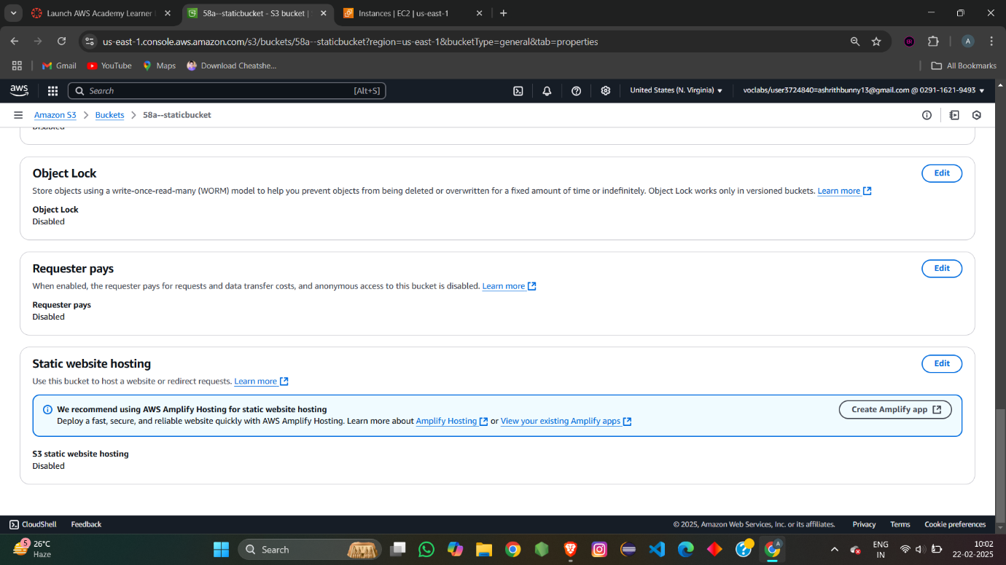

Enable the static webhosting and give the file name 🡪 save the chnages

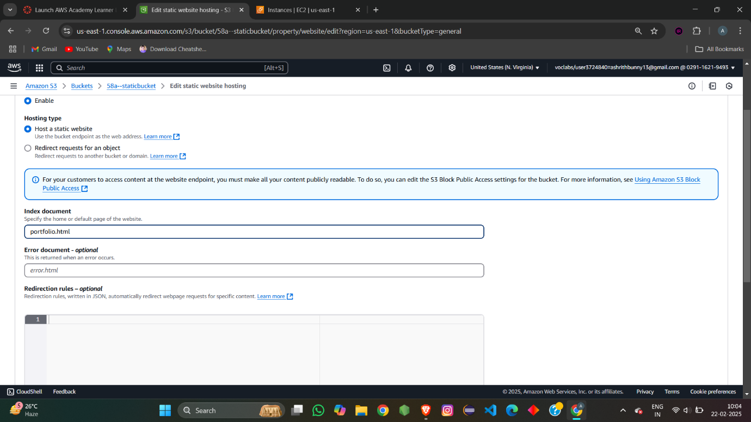

Upload the objects which are mentioned while enabling the static webhosting

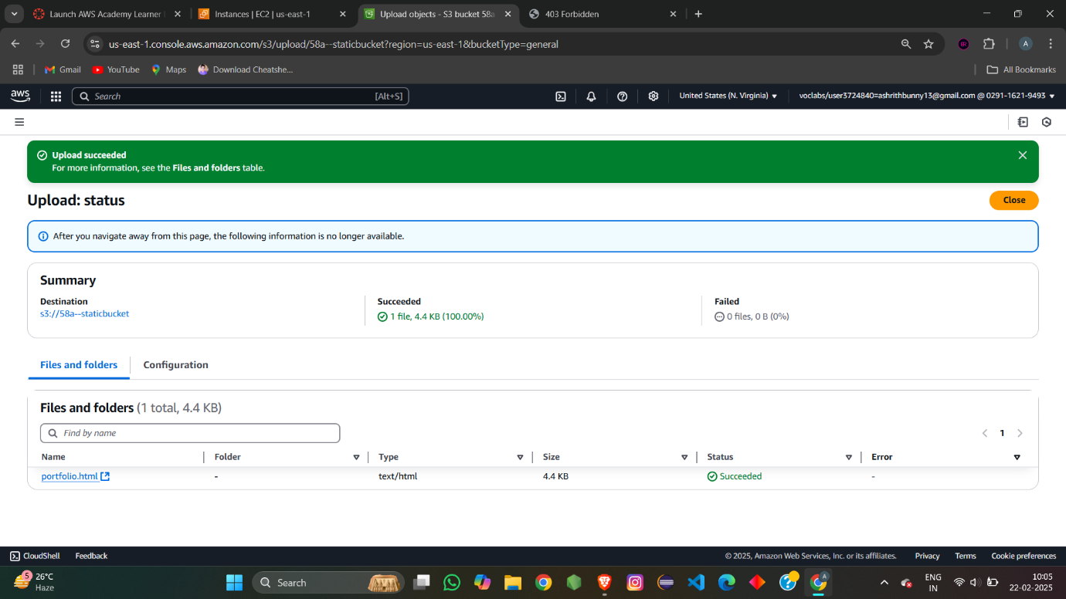

After uploading the object don’t forget to give both bucket level permission and object level permission for the object. hence forward we won’t be able access the object with public URL.

Now go to properties try to access the object with static webhosting url

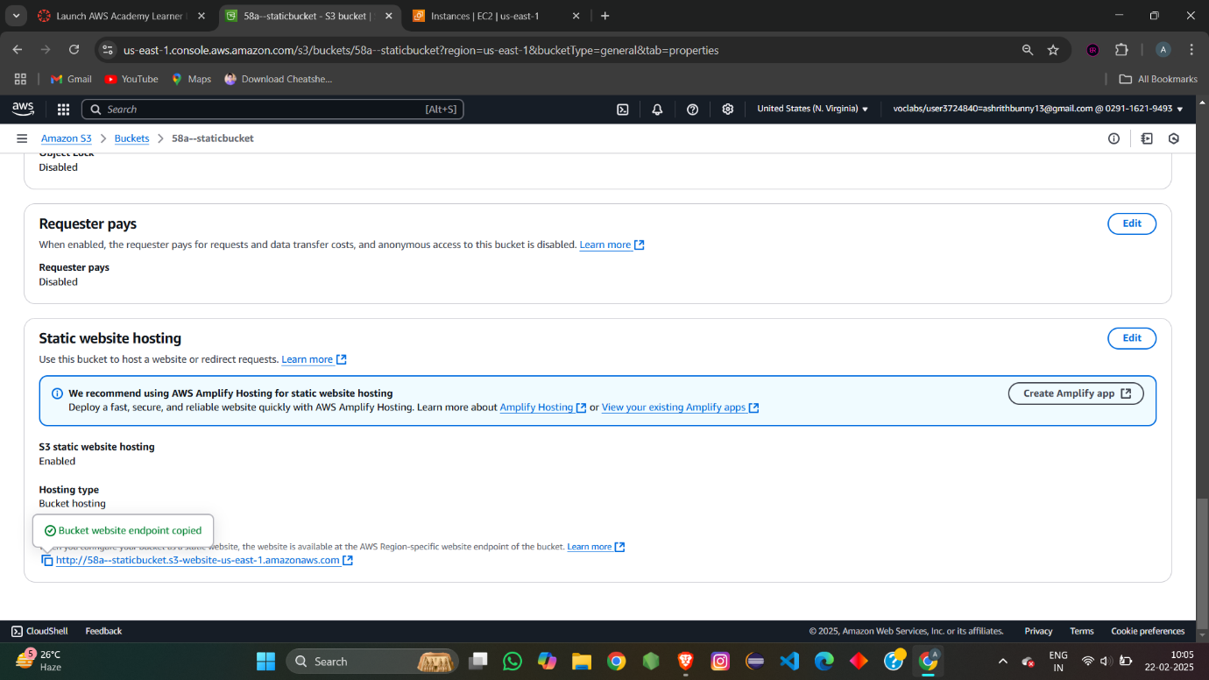

We are able to access the website with the static url provide.

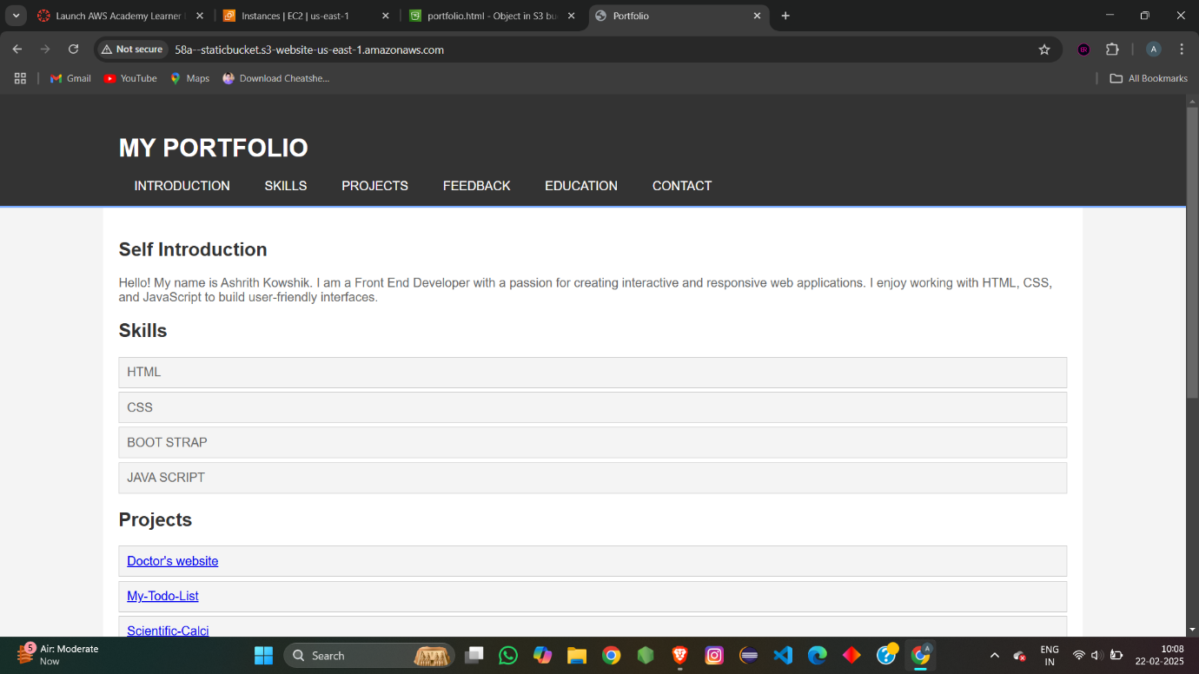

Link:

<http://58a--staticbucket.s3-website-us-east-1.amazonaws.com>

now remove the portfolio obj and insert the new obj with other name error.html

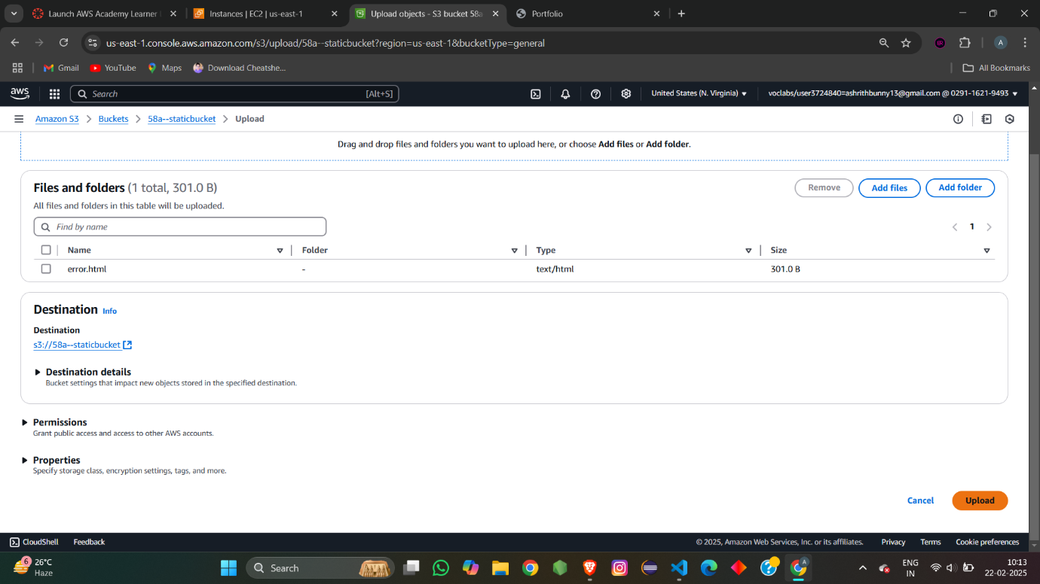

Uploaded new object named portfolio.html

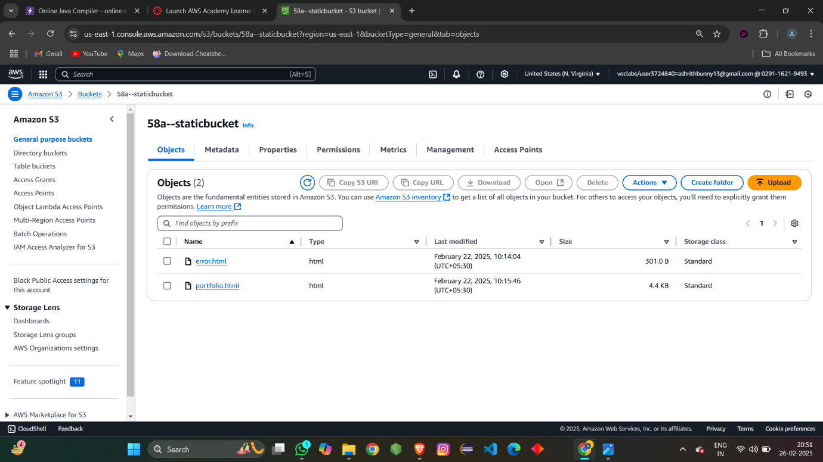

Now if u try to access the static webhosting url we would be ubale to access

We would get the response of error.html

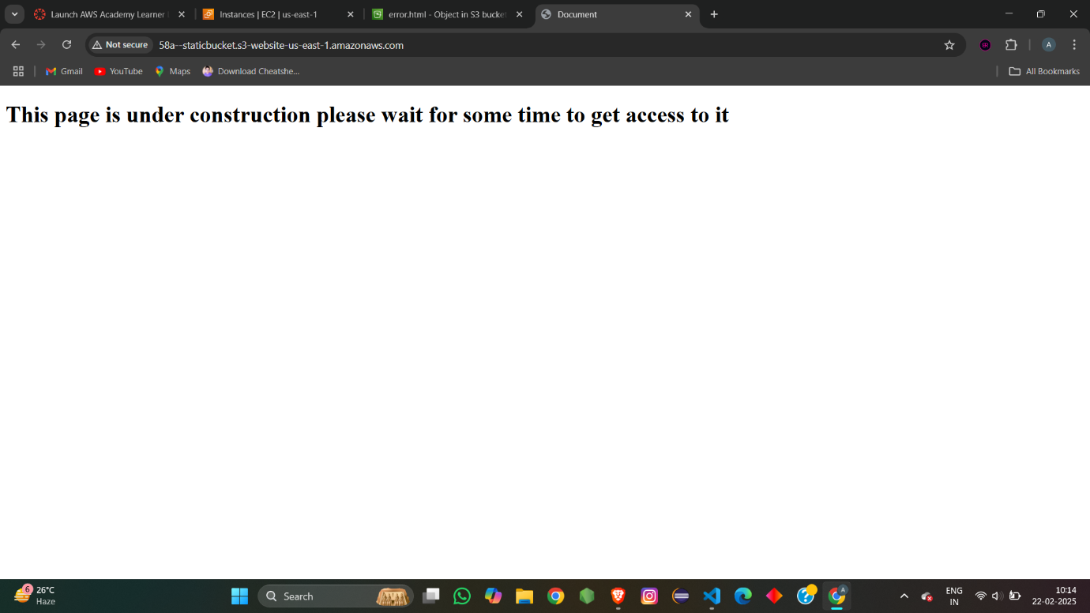

This is because the bucket u have created can only host the object named mentioned while enabling static webhosting . i.e portfolio.html

So when bucket contains portfolio.html it was able to host the object

When the object is removed and inserted new document it would not be abled to host the object and it show the response of error.html file

Cross region replica :

Create two bucket namely source , destination

Create the bucket at two different region to understand cross region

Make sure both the bucket are having Versioning enabled

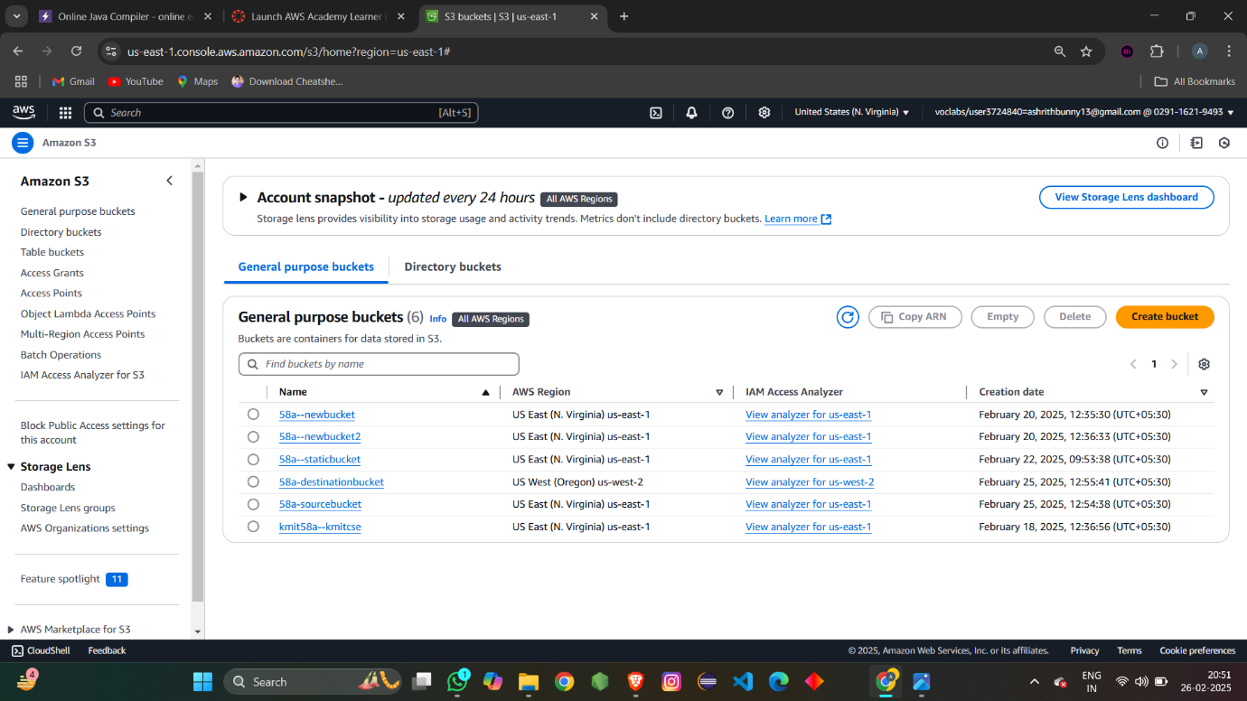

Go to source bucket 🡪 management

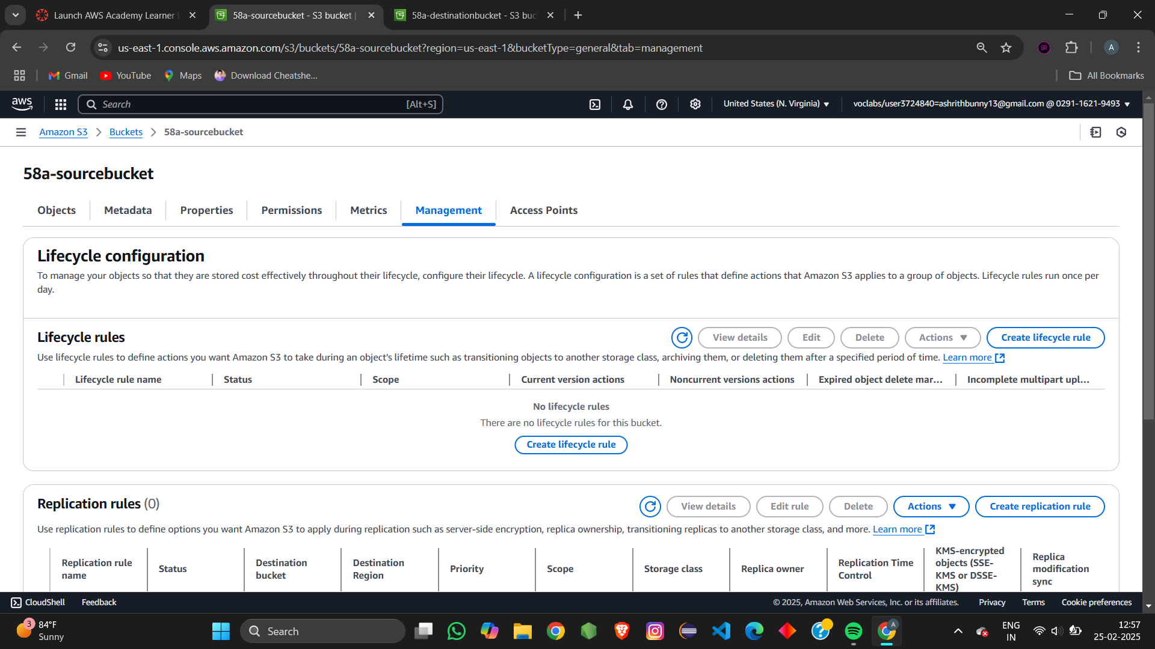

Create a replication rule



Give the replication rule name

Change the source bucket 🡪 apply to all the objects in the bucket

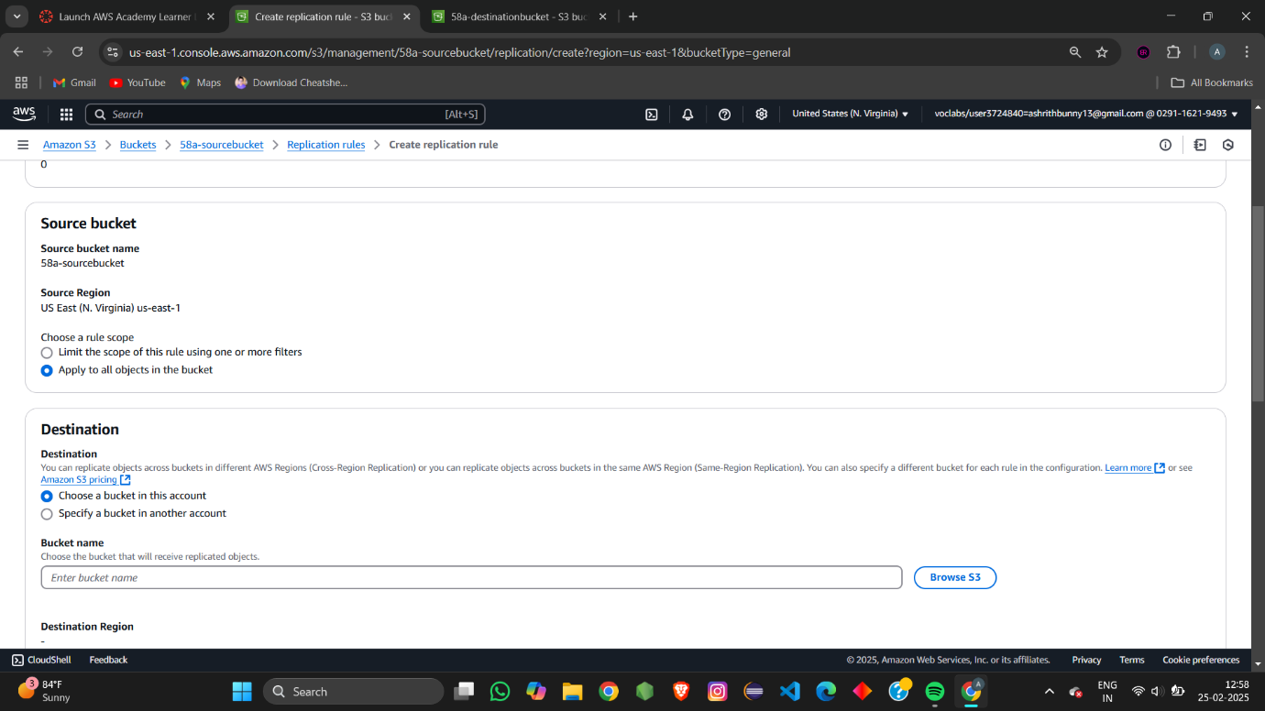

Choose the destination bucket 🡪 browse the bucket

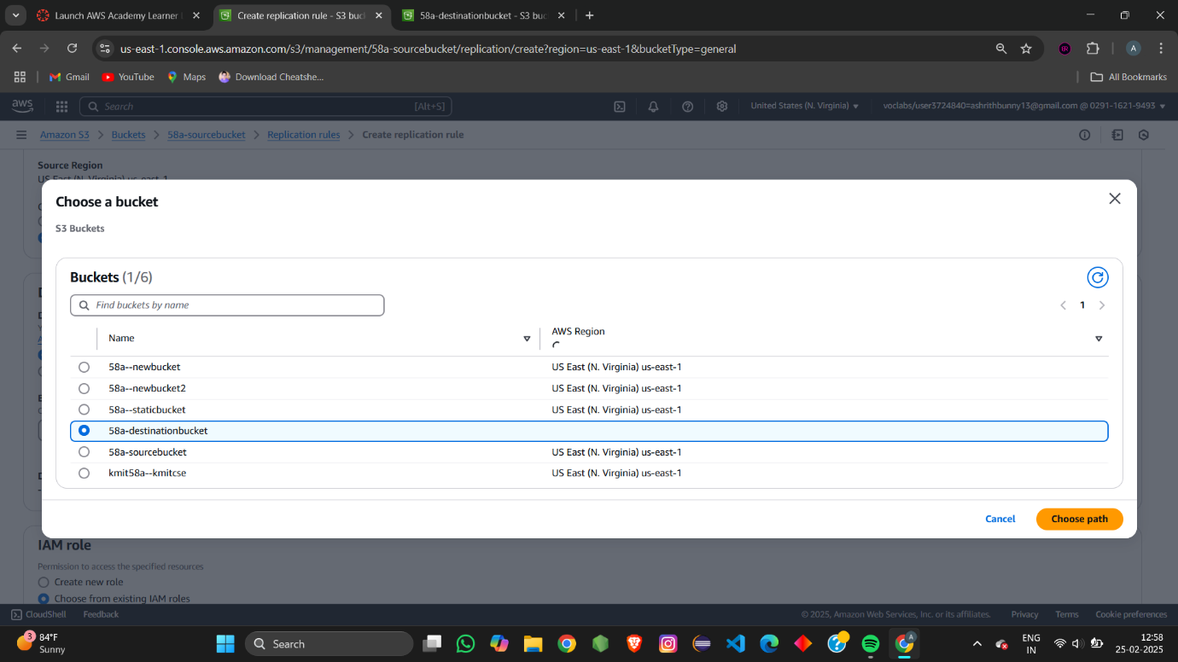

Choose the IAM role 🡪 LabRole

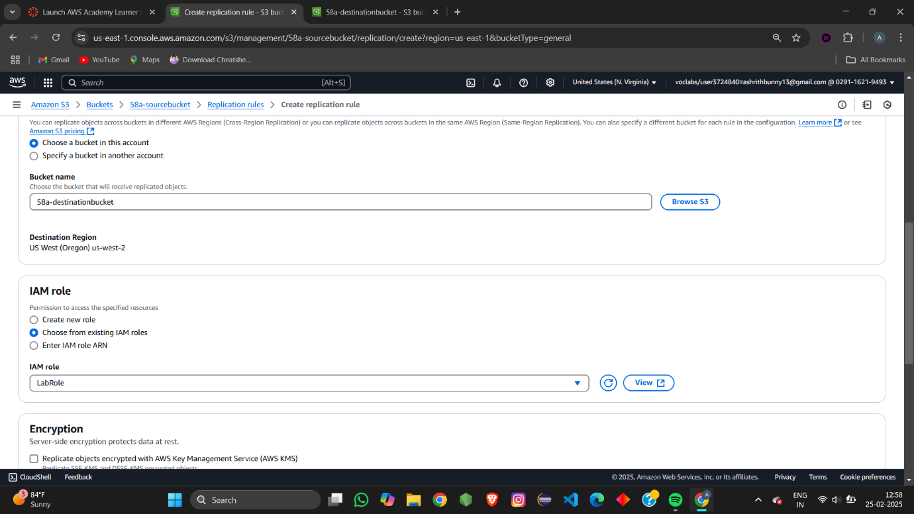

Your replication rule get created and it has the reference to the destination bucket which is created in another region.

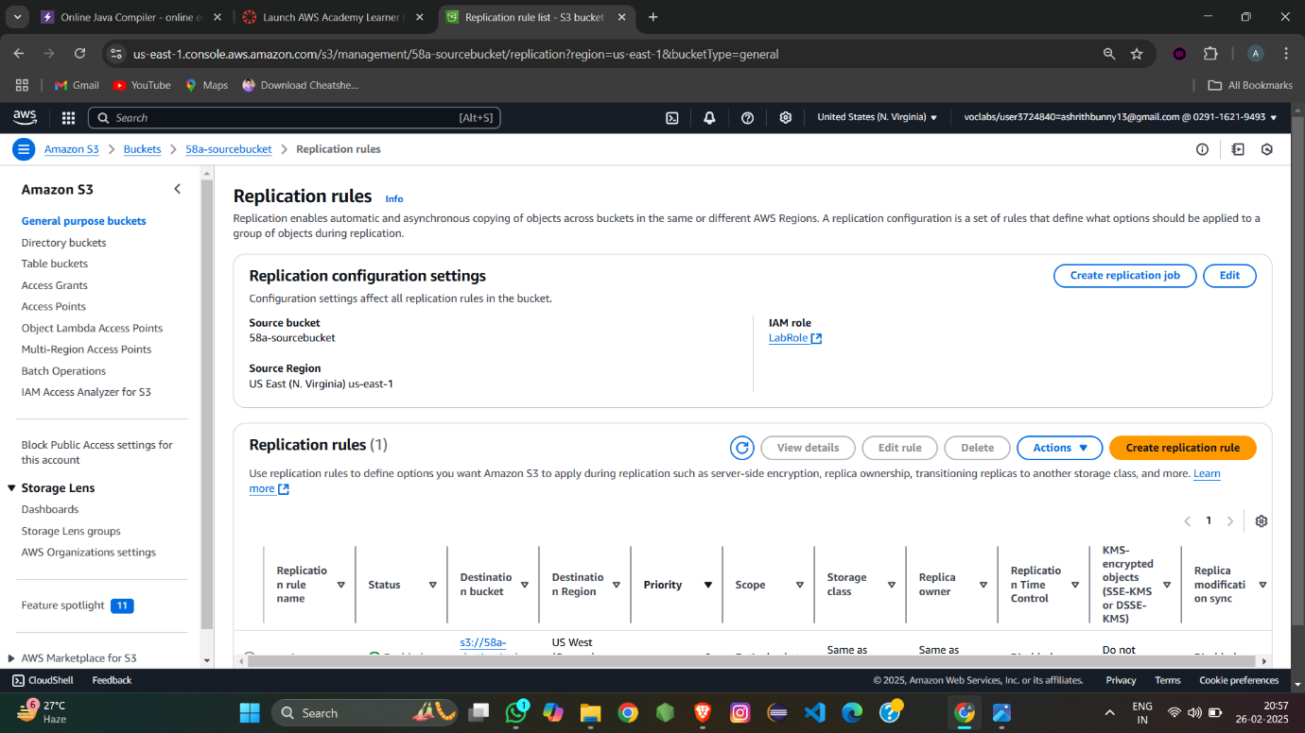

Now try to insert or upload any objects in the source- bucket

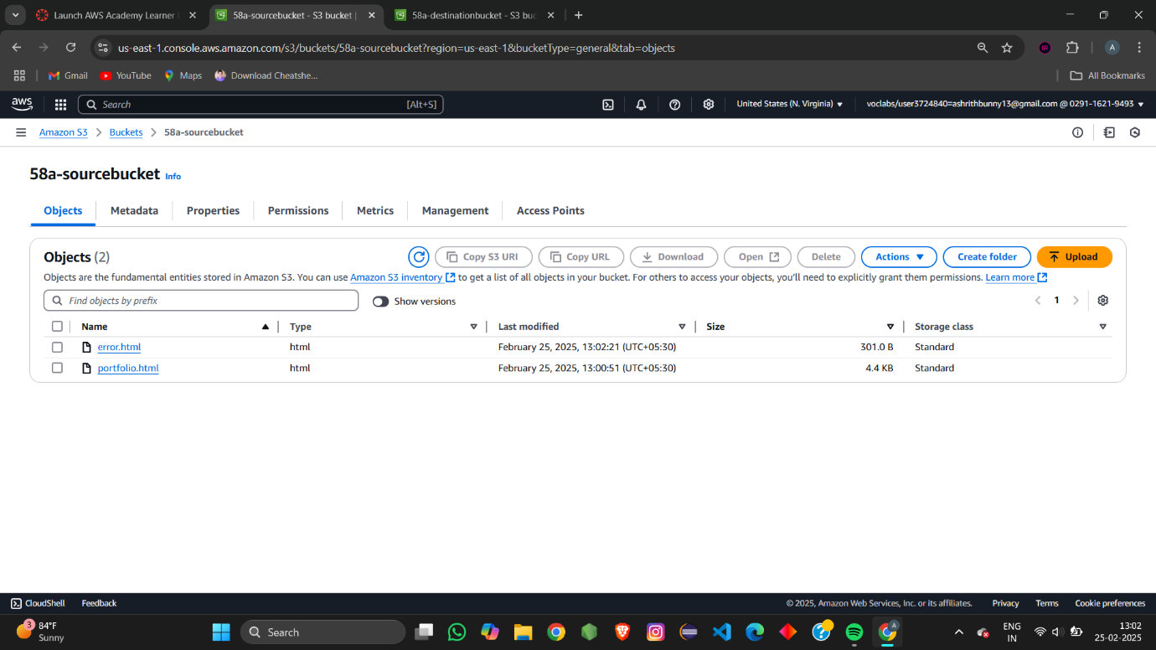

If you refresh the destination bucket these objects get reflected in the destination bucket to

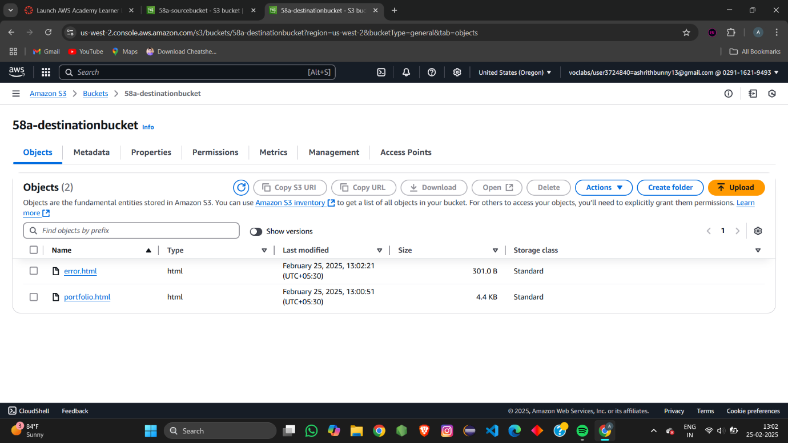This is the concept of cross region replica. with out any changes done in destination everything gets updated automatically without any changes.